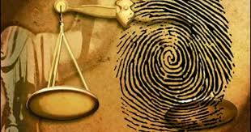

**Boston**

A glance through the historical data of Boston

Starting with the introduction, Boston was founded in the year 1630 by Puritan colonists of England. It plays a vital role in the development of Central American Revolution. Let us check out the history of Boston with respect of crimes and mischiefs. Boston has had a history of epidemic affection during the period of 1636-1689 when a virulent sequence of six smallpox diseases outbroke, that lead to the death of about 10 percent of the population.

Talking about the economic growth, we see that the country has known to be one of the undercrowded places with a mobile population of around 1800 during the times of 1780. Despite all of these, they are known to be one of the fast producers of rum, tobacco and fish.

Boston history in crimes started with America’s entry into the world war in the year 1917.One of the most notorious criminals was Alfred Brady known as ‘Gangster Alfred Brady’. He had gangs of friends who could stand by him to commit robberies at least 300 at one go and murders as well. Years of crime went by until he was shot dead and his friends were custodied during an investigational enquiry. One can not forget the ‘Boston Strangler’ who has strangled 13 women to death in the early 1960s.This still remains a scary nightmare to most of the people in Boston. It is said that the above said guy has won the Grammy award of being the most brutal and cruel stranglers across the world who had the capability of giving varieties of sleep paralysis and nightmares to children and very-old-aged folk of Boston.

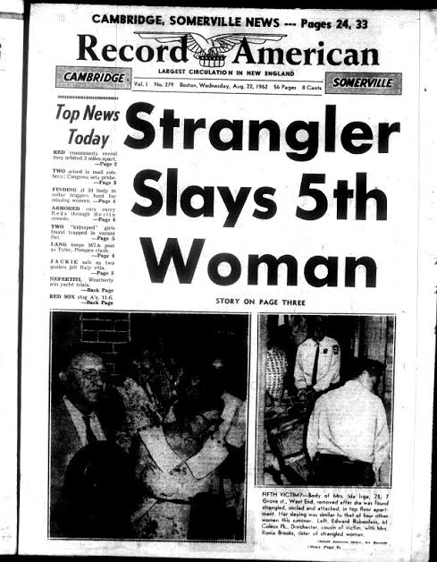

He must have been the ‘Adam’ of Boston who made his successors to have eaten ‘The Forbidden Fruit’ and thus end up in the closure of peace and humaneness across the country.

Reading between the lines of the history of Boston ,one should be excited to analyze the rate of crimes committed at this twenty first century when the phase of world wars have been apparently come to a stop,that has been claimed by the Boston Bureau as the influential factor that led to the pathetic situation of the country now.

The history got into my nerves and I thought why not for an analysis of the data set of Boston Crime. The findings are frightening and not as frightening as I thought it would be.

You have seen only the movies. Now let’s go for the real TRUTH that is fascinating.

The types of crime in Boston counted around 25.The most happening among them was Motor vehicle accident response and Larceny. Simple assault and Vandalism are also vital among the lists of crime rates. Analyzing the column of Larceny, we come to know that there are around 17961 records each having a column of 17 each. The peak time of this crime to occur is during 4-6pm and the least probable time of happening is 5pm. Hence the folks must have been sleeplessly and carefully spending their evenings mostly at home so as to protect themselves and their family from being victimized.

In Massachusetts, the crime rate is 354 per 100k people comparing with the population rate 394 which is astonishing. About 90 percent of the crowd is corrupted in minds unfortunately. This is what the newspaper says...Robbery, rape and homicide falls under the wide range of categories of crimes being committed. But when comparing with other cities of United states, we can praise the country Boston for being not the prize winning among the crime countries . Fortunately, the possibility of being an assaulter is 1 in 37 which is a happy news.

Although our place has struggled a lot to provide accurate data ,we can never trust the precision of the data ,as the people of Boston who are not really trustworthy. Most of the crimes happen on Fridays, Saturdays and Mondays which is the weekend and onset of week days probably when everyone is idle.

The affected cities of Boston are Dorchester, South-end and Roxbury.

Concluding the analysis, let us not underestimate the country for its history and spoil their name among the cities of US. Yet we cannot ignore the crime tour warnings we find on web, which means Mobsters, Criminals, Gangsters and Heists await you at Boston, therefore be at ease and face the consequences if you want to tour across Boston.